Personal Study Plan
Define the objective or focus of the essay:
My focus is to capture the connection between people and animals in street and landscape photography.
The relationship between the practical work and the focus of the study:
My practical work in street photography will involve actively going out into urban and rural environments to capture images of people in their everyday life’s, graffiti, street-art murals and o I will be focusing on how people coexist within a shared habitat whether this is natural landscape such as the mountains and beaches in Ireland and the urban streets in Manchester and Thailand. The forms of public art. This will allow me to engage directly with the subject matter and experiment with lighting, angles, composition and the best ways to represent the art. My focus of the study involves analysing the social, cultural and artistic features of the environment. I will see how the street reflects community identity and challenges societal norms.
Sources to be used:
Books (at least THREE): | Websites: | Other sources:
In the Face of History  Black Dog Publishing  Find Your Frame  Craig Whitehead  Metropolis  Alan Schaller  Mastering Landscape  David Taylor  LANDSCAPE PHOTOGRAPHY  Glem Randall | https://atmstreetart.com  https://www.banksy.co.uk  https://streetartutopia.com  https://www.globalstreetart.com  https://www.graffitistreet.com  https://urbanartassociation.com | “Everybody Street” Tv Show  “In No Great Hurry “  Tv Show  “Tales By Light”  Netflix  “Wrong Side Of The Lens”  Youtube Series  “Tales by Light”  Netflix

List the pieces of work that you will analyse in the study. Identify reasons for choosing these particular pieces and points that may be highlighted in the analysis. Mark the primary source/s with *
Name of piece: | Reasons for choice/Points to be raised:
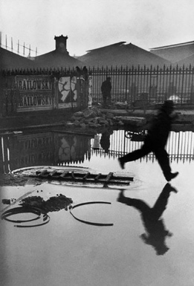  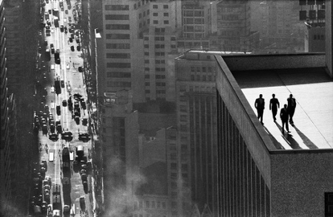 | HENRI CARTIER-BRESSON  He brought a new aesthetic and practice to photography. He has the ability to find the ‘decisive moment’ the perfect instant when everything in the frame comes together which helps show how street art interacts with people and its environment naturally.  RENE BURRI  He focuses on street scenes and human stories often highlighting the relationship between people and their surroundings. His photos have a strong sense of composition and mood, helping you see how to frame street art within its social and cultural context.  PAUL STRAND  He is known for his sharp, detailed images and for capturing everyday life with a modernist approach. Strands photography combined technical precision with a deep social consciousness, influencing generations of photographers.
Visit/s made/to be made:
London Gallery

Possible conclusion/s to the study:
I hope to conclude through my research how people adapt to their environments and how farmland and busy streets juxtapose each other.

